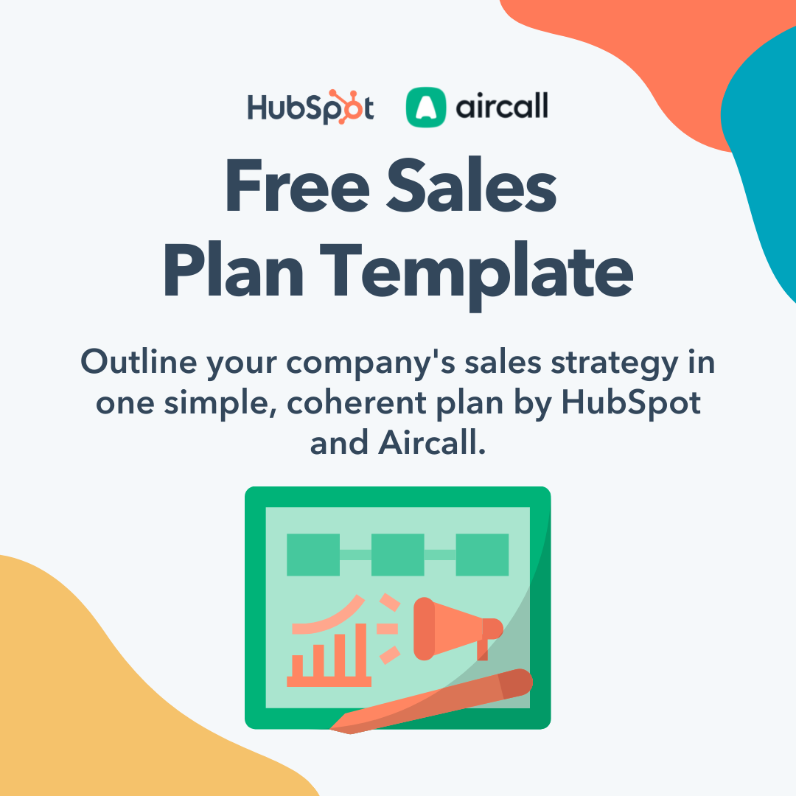

Hi There.

Thanks for Downloading This Resource.


You Can Edit Your Own Version in One of Two Ways:
- Edit this version to fit your needs.
- Go to “File” > “Download As” > “Microsoft Word” to Download.

How to Use This Template

Thanks for downloading HubSpot and Aircall’s Sales Plan Template!

This resource is built for you to outline your company’s sales strategy. Included are the sections that exist in most sales plans, as well as prompts for you to fill out your company’s tactics and information. Simply erase the instructions under each header and replace them with what makes sense for your business. You can choose from either a plain text template or a customizable designed variation that you can update with your brand logo and colors.

Once complete, this plan can be shared with investors, company leadership, the sales team, or whomever you see fit.

Keep in mind, this template is designed to be completely customized by your company. If you feel there are sections included that you would rather omit, you are encouraged to make those changes as you see fit for your business.

Yes, it’s possible to love your sales CRM.  Sales Hub eliminates friction by bringing all your tools and data together on one easy-to-use, powerful CRM platform your whole team will love. |  | 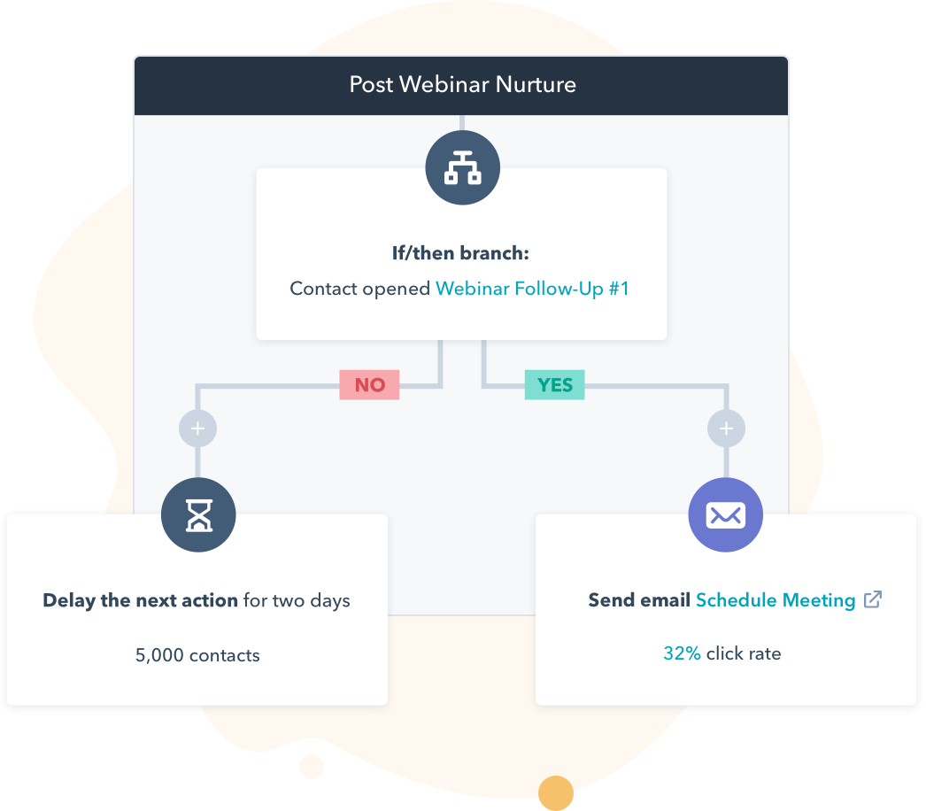
 | Get Started With Sales Hub

Keep scrolling to templates
↓↓↓

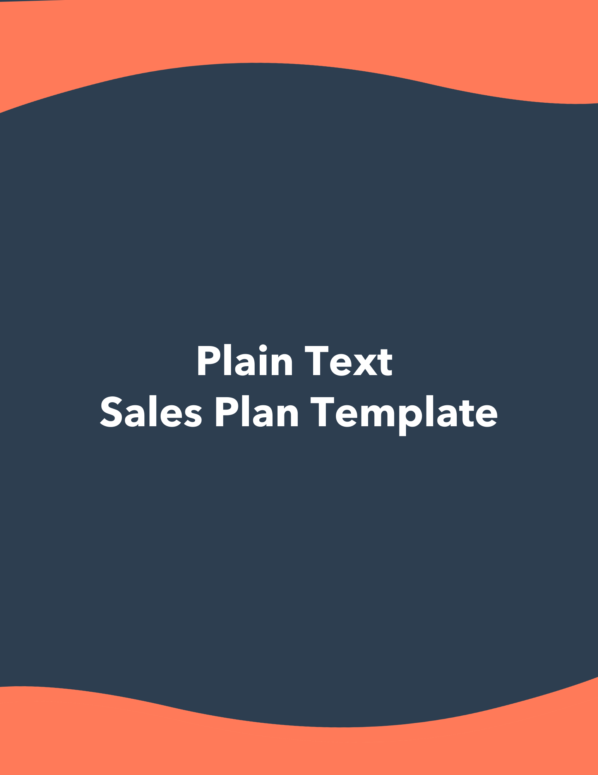

[Company Logo]

[Company Name]

Sales Plan: [Period of Time, i.e. Q1 2019, FY 2020]

Written by: [Your Name]
[Your Email]

Table of Contents

- Mission and Background…………………….…………………….………...…………………##
- Team……………………………………………………….…….…….…………..……...……..##
- Target Market……………………………………...……………………….………………...…##
- Tools, Software, and Resources…………………………………….……………….…………##
- Positioning…………………….………….………….….….………….….…….….….…....…..##
- Marketing Strategy……………………….……….….….…….………………….….………...##
- Prospecting Strategy………………….…………….………………..…..………….……...…##
- Action Plan….………...….….….…..…...……….…….....…….......…….....…..…….…...….….…..##
- Goals.………………………….….….…………….….….……….………….………...………##
- Budget………………………………..…………………………….…...…………………...…##

Mission and Background

In this section, give context as to why your business exists. Cover your mission statement, vision statement, and an abridged company history for readers to understand the context of the business.

Mission Statement

[Enter your company’s mission statement]

[We believe that every individual deserves the opportunity to explore their passions and dreams. Our mission is to empower individuals on their journey to finding homes that not only meet their physical needs but also nurture their personal growth and aspirations.]

[We prioritize the safety and security of our clients above all else. Our mission is to ensure that the properties we recommend meet the highest safety standards, giving our clients peace of mind in their homes.]

[We believe that a comfortable and accessible home is fundamental to a fulfilling life. Our mission is to assist our clients in finding properties that cater to their physiological needs, allowing them to age in place with dignity.]

[Our mission culminates in helping our clients make informed real estate decisions. We facilitate seamless transactions, negotiate on their behalf, and ensure they secure properties that align with their unique needs and desires.]

[We don't consider our mission fulfilled with a successful transaction. We aim to build lasting relationships with our clients, providing ongoing support and resources throughout their real estate journey. Our mission is to be their trusted partner for years to come.]

[At Quinby & Partners, our mission is to elevate the real estate experience for all individuals, addressing their holistic needs while guiding them through the real estate buying and selling process. We are dedicated to ensuring that their golden years are marked by comfort, fulfillment, and the joy of finding the perfect place to call home.]

Vision Statement

[Enter your company’s vision statement]

[At Quinby and Partners, our vision is to redefine the real estate experience for individuals by placing their well-being and aspirations at the heart of everything we do. We envision a future where everyone enjoys the opportunity to live in a home that fulfills not only their basic needs but also their dreams and desires, guiding them through the buying and selling processes of their unique real estate journey.]

[We see a future where everyone can flourish in their golden years, embracing self-actualization as a fundamental part of their lives. We envision helping them find homes that ignite their passions and support their journey toward self-discovery and fulfillment.]

[In our vision, every homeowner experiences a newfound sense of self-esteem and confidence because their home reflects their true identity and values. We aspire to empower them to make real estate decisions that boost their self-esteem, transforming houses into sources of pride and self-assurance.]

[Our vision is one where safety and security are non-negotiable rights for every homeowner. We see ourselves as guardians, ensuring that each property we recommend provides the highest levels of safety and peace of mind.]

[At Quinby & Partners, our vision is to be the beacon of light guiding buyers and sellers to homes that enhance their lives, honor their aspirations, and celebrate their individuality. We are driven by a commitment to their well-being, happiness, and the promise of a brighter future in a place they will proudly call home.]

[We aspire to build lasting relationships, fostering loyalty that endures long after the transaction is complete. In our vision, we remain their steadfast partner, providing ongoing support, resources, and a trusted hand to hold throughout their real estate journey.]

Company History/Story

[Enter your company’s story and/or abridged history]

Unique Selling Proposition

[Enter your company’s vision statement]

[We understand that your retirement years are a time for self-discovery and fulfillment. Our USP is to help you find a home that not only meets your basic needs but also aligns with your passions and dreams. We're not just real estate agents; we're your partners in crafting the next chapter of your life.]

[Our commitment doesn't end with a successful transaction. Our USP is to build enduring relationships with you, providing ongoing support, resources, and a reliable partner throughout your real estate journey. We're here for you not just today but for years to come.]

[At Quinby & Partners, our unique selling proposition isn't just about selling houses; it's about enhancing the quality of your life in your golden years. We're dedicated to making your real estate experience a deeply fulfilling and transformative one, focused on your well-being, happiness, and the place you'll proudly call home.]

Team
Who are the leaders of your sales department, and how is the rest of the department structured?

Sales Leadership

[Name the leaders of your sales department and their titles. Optionally, you can add a photo of the sales leaders and/or a professional bio.]

Sales Team Structure

[Explain the organization of your sales department. You can structure this section by region, team, or hierarchy. If you have an org chart filled out, this would be the perfect place to input a copy or a screenshot of it.]

New Hires

[How will your team grow? Explain where the gaps in your head count are and what will be done before the spots are filled.]

Target Market

Talk about who your product or service is aimed towards. Identify your key prospect attributes, who should be omitted from sales efforts, and the region you target.

Locations Targeting

[Identify the physical location of your target market. If you are a nationwide company, identify your strategy for whichever locations take precedence (if any) and what your nationwide rollout strategy is. If you are a regionally-limited company, explain why.]

Buyer Personas

[Who are you targeting? Buyer personas are semi-fictional representations of your ideal customer based on market research and real data about your existing customers. Outline these ideal customer personas here, and if you’re creating these personas from scratch, try using this free Buyer Persona Generator.]

[Older individuals aged 60-75+ interested in buying or selling real estate]

[Family members or caregivers involved in real estate decisions for older individuals.]

[Local senior communities, senior centers, and organizations.]

Omissions

[Let’s talk about tradeoffs. To succeed, it’s just as important to know who not to target as is it to know who to target. Outline the people, businesses, and/or buyers who are unqualified to pursue as prospects and why.]

Customer Experience

[What are the customers' perceptions and experience with your business or brand? Customer experience includes every interaction they have with you—from navigating your website to talking with your customer service team.

Describe your customer journey, including the touch points and communication channels they use to discover products, make purchases, and reach out to support teams. If you’re in the process of building a customer service department, use these best practices to get started.]
Tools, Software, and Resources

Explain what resources the sales team uses to accomplish its goals. This includes CRM software, documentation, customer references, and any other tools used in selling.

Software

[Identify the CRM software used and how it is used in every stage of the buying cycle. If you do not have a CRM yet, try HubSpot CRM -- it’s completely free! If there are any other software employed in the sales strategy, identify them and their purposes here as well.]

Tools and Resources

[Identify the documentation and resources salespeople can use to do their jobs. This may include sales enablement tools, productivity and collaboration tools, customer case studies, suggested negotiation practices, tools for recording and analyzing sales calls to improve close rates, and more.

Sales leaders can leverage lots of tools to set up efficient workflows that correspond to your overall sales strategy. For example, Aircall lets you combine a cloud-based phone system with your current software integrations—giving you all the tools and data needed to optimize sales processes in a single platform.

In a nutshell, if there’s something your business can offer to strengthen a salesperson’s performance, identify it here.]

Relationship Between Sales and Customer Support

[How do your sales and customer service teams work together? Sales teams work to reel customers in, and support teams keep them around, but sharing information is key to make sure both departments perform optimally. If you don’t have a system for data sharing, there are lots of tool integrations you try to increase visibility and alignment.]

Sales Training

[List all the training you provide for your sales team to achieve their goals.]

Positioning

Think about your place in your industry. Anyone reading this part of the plan should know what your strengths, weaknesses, and comparisons to competing companies are.

Market Condition

[Speak to the market conditions in the industry. How is your industry performing in general? It could also be beneficial to run a Porter’s Five Forces Analysis with the template in this kit.]

Value Prop

[In general, what benefit does your business, product, or service offer that would make someone want to become a customer? Identify the problem to which you are the solution.]

Pricing Strategy

[What is your pricing strategy and how was it developed? Here is a good time to talk about best practices around discounting.]

Marketplace Risks

[Identify the risks in your marketplace or industry. This could be a strategic risk, compliance and regulatory risk, financial risk, or operational risk.]

Competitive Advantages

[What makes your business unique and comparatively stronger than competitors? What do you offer that no other company, product, or service does, or does as well?]

Competitor Analysis

[List your top competitors as well as the following information for each competitor:]

- Comparative Strength – What are your company’s assets that this competitor does not have?
- Comparative Weakness – In what areas or attributes do your competitors outperform you?
- Counterpoints – If a comparative weakness is mentioned in sales negotiations, which counterpoints can be used to address those weaknesses?

Competitor Name | Comparative Strength(s) | Comparative Weakness(es) | Counterpoint(s)
Competitor A
Competitor B
Competitor C

New Market Opportunities

[Identify the new market opportunities that your business can expand into. This could be growing into a vertical industry or segment, possible new product lines, exploring new channels, or targeting different consumer niches.]
Marketing Strategy

Provide an overview of your marketing strategy. This should not be a copy and paste of your entire marketing plan, but rather a rundown of what sales should know about brand awareness and lead generation.

Included below are some of the most popular forms of marketing today. If your company does not use some of these, or if you use others not included here, feel free to delete and add sections respectively.

[Position our real estate agency as the go-to advocate for older individuals aged 60-75+ by providing valuable content and resources related to health, fitness, community involvement, accessibility, and walkability in real estate.]

Inbound Marketing:
Website Marketing
[Briefly explain your blogging and content marketing strategy and who on the team should be consulted for questions.]

[Optimize your website with SEO-friendly content that addresses the unique needs of older individuals. Create dedicated landing pages highlighting the senior-friendly features of different neighborhoods, including walkability scores and community amenities.]

[Optimize the website for accessibility and user-friendliness.]

[Create dedicated landing pages for each interest area (health, fitness, community
involvement, etc.).]

[Publish regular blog posts, articles, and resources addressing the unique needs of
older individuals in real estate.]

Blogging and Content Marketing
[Briefly explain your blogging and content marketing strategy and who on the team should be consulted for questions.]

Video Marketing
[Briefly explain your video marketing strategy and who on the team should be consulted for questions.]

Event Marketing
[Briefly explain your industry event marketing strategy and who on the team should be consulted for questions.]

Demand Generation Marketing
[Briefly explain your demand generation marketing strategy and who on the team should be consulted for questions.]

Customer Marketing
[Briefly explain your customer marketing and referral strategy and who on the team should be consulted for questions. This includes all activities to drive existing customer loyalty and retention.]

Email Marketing
[Briefly explain your email marketing strategy and who on the team should be consulted for questions. This includes email newsletters, promotions, and retargeting, but not outbound cold emails.]

Social Media Marketing
[Briefly explain your social media marketing strategy and who on the team should be consulted for questions.]

Outbound Marketing:

Direct Mail Marketing
[Briefly explain your direct mail marketing strategy and who on the team should be consulted for questions.]

Outbound Email Marketing
[Briefly explain your outbound email marketing strategy and who on the team should be consulted for questions. This could include cold email marketing for B2B businesses.]

Cold calling
[Briefly explain your cold calling marketing strategy and who on the team should be consulted for questions.]

Prospecting Strategy

What steps should sales teams take to qualify leads generated by marketing and reach out to them?

Criteria for Outreach

[What criteria should a prospect meet before sales reaches out to them? Establish must-have attributes so salespeople only spend time working on qualified contacts.]

Inbound Prospecting Strategy

[Talk about your company’s tactics for connecting with contacts on an inbound level, like following up on inbound emails, meetings at industry events, or social selling.]

Outbound Prospecting Strategy

[Talk about your company’s tactics for cold calls and emails, if applicable.

Cold outreach is an essential prospecting strategy for B2B businesses, and should include plans for generating leads, nurturing leads, and following up with warm contacts. This guide has more tips for building a successful cold calling strategy.]

Referral Strategy

[Talk about your company’s plans for generating and increasing recommendations and word of mouth. Use this to grow your customer base through your existing customers.]

Customer Feedback Process

[What is the customer feedback process and how will your business use feedback to improve the sales cycle? Here’s an example of how you can set up a customer feedback system to continuously optimize sales performance and improve your products/services.]
Action Plan

Outline the concrete actions the sales team will take in order to achieve the company’s goals. How many calls should be made, how many locations will be dropped in on, how many will work on high-profile clients, etc.

Goal #1

[Explain the first goal and copy/paste this section as needed for more tactics in your action plan.]

[Establish Brand Recognition and Trust]
- Objective 1:
  - Increase website traffic by 20% within the first six months by optimizing content for relevant keywords and providing valuable resources.
- Objective 2:
  - Achieve a 15% increase in social media engagement (likes, shares, comments) over the course of one year through consistent and engaging content sharing.
- Objective 3:
  - Gain 10 positive online reviews and testimonials from satisfied older clients within the first year to build trust and credibility.

Goal #2
[Educate and Empower Older Clients]
- Objective 1:
  - Grow the email subscriber list by 15% in the first six months by offering valuable resources and incentives for sign-up.
- Objective 2:
  - Host a minimum of four webinars or live streams within the first year, with an average attendance rate of at least 50 participants per session, to educate older clients on real estate topics relevant to their needs.
- Objective 3:
  - Publish a minimum of two blog posts or articles per month addressing the unique needs and interests of older individuals in the real estate market.
Goal #3
[

Tactic #1

[Explain the first tactic and copy/paste this section as needed for more tactics in your action plan.]

Goals

What are your sales targets? These goals are contingent on how often you plan to update your sales plan.

Revenue Targets

[What is your targeted revenue – booked and live – for the end of the period?]

Deal Target

[How many deals do you intend to close by the end of the period?]

Units Sold Target

[If applicable, how many units do you want sold by the end of this period? If your business sells multiple products, specify your target for each product line.]

Sales Cycle Target Length

[What is the length of your sales cycle or sales pipeline? Track the length and optimize your sales process. The shorter your sales cycle, the faster you can acquire new customers.]

Other Key Sales Metric(s) Target

[If you have any other metrics you are tracking for sales (software MRR, customer retention, etc.), define and outline the expectations here.]

Budget

Outline the budget for your sales initiatives, including total base salaries, bonus/commission structure, resource and software expenses, discounting, training, travel costs, food, and more.

It’s helpful to compare the sales budget with your sales forecast, which you can build here.

Did We Miss Something?

Add another section here if you need it.

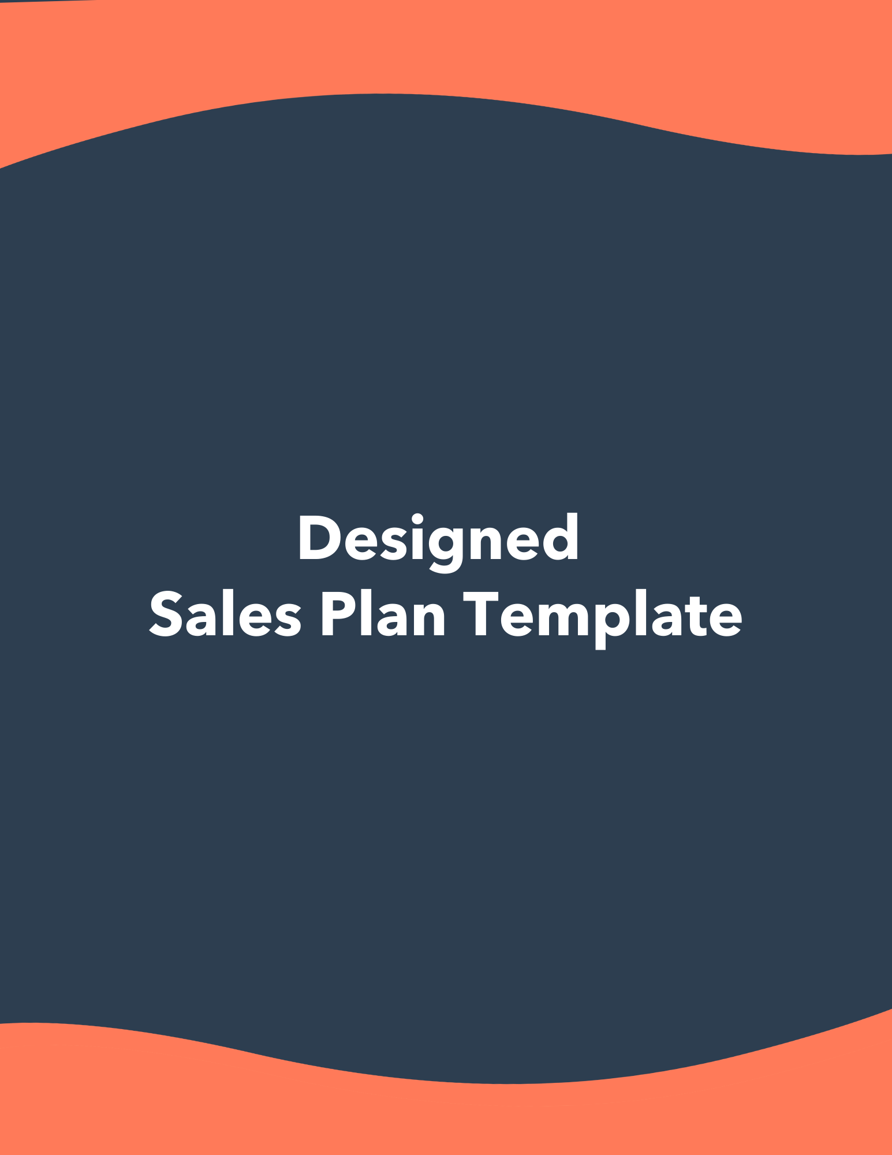



Company Name
Sales Plan

Our Objective | Summarize the role your company’s sales department plays to the growth of your business. This statement should reflect your overall strategy outlined in the pages that follow.
Authors of Document | [Name #1]  [Email Address #1]  [Name #2]  [Email Address #2]


Table of Contents | Mission and Background  Team  Target Market  Tools, Software, and Resources  Positioning  Marketing Strategy  Prospecting Strategy  Action Plan  Goals  Budget | #  #  #  #  #  #  #  #  #  #

Mission and Background

Mission Statement
[Company name] is a company headquartered in [location of HQ] with offices in [satellite office locations]. The company’s mission is to [mission statement].

Vision Statement
The company’s mission is to [vision statement].

Company History/Story
[Enter your company’s story and/or abridged history]

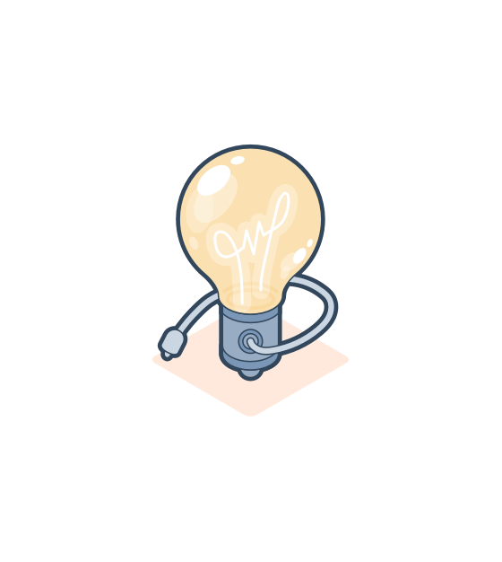  Pro Tip: | In this section, give context as to why your business exists. Cover your mission statement, vision statement, and an abridged company history for readers to understand the context of the business. You can use these mission statement templates to get started if you need help.

Team

Sales Leadership
[Name the leaders of your sales department and their titles. Optionally, you can add a photo of the sales leaders and/or a professional bio.]

Sales Team Structure
[Explain the organization of your sales department. You can structure this section by region, team, or hierarchy. If you have an org chart filled out, this would be the perfect place to input a copy or a screenshot of it.]

New Hires
[How will your team grow? Explain where the gaps in your head count are and what will be done before the spots are filled.]

  Pro Tip: | Check out HubSpot’s Organizational Chart Templates offer to visualize your team structure.

Target Market

Locations Targeting
[Identify the physical location of your target market. If you are a nationwide company, identify your strategy for whichever locations take precedence (if any) and what your nationwide rollout strategy is. If you are a regionally-limited company, explain why.]

Buyer Personas
[Who are you targeting? Buyer personas are semi-fictional representations of your ideal customer based on market research and real data about your existing customers. Outline these ideal customer personas here, and if you’re creating these personas from scratch, try using this free Buyer Persona Generator.]

Omissions
[Let’s talk about tradeoffs. To succeed, it’s just as important to know who not to target as it is to know who to target. Outline the people, businesses, and/or buyers who are unqualified to pursue as prospects and why.]

Customer Experience
What are the customers' perceptions and experience with your business or brand? Customer experience includes every interaction they have with you—from navigating your website to talking with your customer service team.
Describe your customer journey, including the touch points and communication channels they use to discover products, make purchases, and reach out to support teams. If you’re in the process of building a customer service department, use these best practices to get started.]

  Pro Tip: | The customer journey is crucial to understand in your sales process. You can use these Customer Journey Map Templates to outline your touchpoints throughout the experience.

Tools, Software, and Resources

Explain what resources the sales team uses to accomplish its goals. This includes CRM software, documentation, customer references, and any other tools used in selling.

Software
[Identify the CRM software used and how it is used in every stage of the buying cycle. If you do not have a CRM yet, try HubSpot CRM – it’s completely free! If there are any other software employed in the sales strategy, identify them and their purposes here as well.]

Tools and Resources
[Identify the documentation and resources salespeople can use to do their jobs. This may include sales enablement tools, productivity and collaboration tools, customer case studies, suggested negotiation practices, tools for recording and analyzing sales calls to improve close rates, and more.
In a nutshell, if there’s something your business can offer to strengthen a salesperson’s performance, identify it here.]

Relationship Between Sales and Customer Support
[How do your sales and customer service teams work together? Sales teams work to reel customers in, and support teams keep them around, but sharing information is key to make sure both departments perform optimally. If you don’t have a system for data sharing, there are lots of tool integrations you try to increase visibility and alignment.]

Sales Training
[List all the training you provide for your sales team to achieve their goals.]

  Pro Tip: | Sales leaders can leverage lots of tools to set up efficient workflows that correspond to your overall sales strategy.  For example, Aircall lets you combine a cloud-based phone system with your current software integrations – giving you all the tools and data needed to optimize sales processes in a single platform.

Positioning

Market Condition
Speak to the market conditions in the industry. How is your industry performing in general? It could also be beneficial to run a Porter’s Five Forces Analysis with the template in this kit.]

Value Prop
[In general, what benefit does your business, product, or service offer that would make someone want to become a customer? Identify the problem to which you are the solution.]

Pricing Strategy
[What is your pricing strategy and how was it developed? Here is a good time to talk about best practices around discounting.]

Marketplace Risks
[Identify the risks in your marketplace or industry. This could be a strategic risk, compliance and regulatory risk, financial risk, or operational risk.]

Competitive Advantages
[What makes your business unique and comparatively stronger than competitors? What do you offer that no other company, product, or service does, or does as well?]

Competitor Analysis

[List your top competitors as well as the following information for each competitor:]

Comparative Strength | What are your company’s assets that this competitor does not have?
Comparative Weakness | In what areas or attributes do your competitors outperform you?
Counterpoints | If a comparative weakness is mentioned in sales negotiations, which counterpoints can be used to address those weaknesses?

New Market Opportunities

[Identify the new market opportunities that your business can expand into. This could be growing into a vertical industry or segment, possible new product lines, exploring new channels, or targeting different consumer niches.]
Competitor Name | Comparative Strength(s) | Comparative Weakness(es) | Counterpoint(s)
Competitor A | TBD | TBD | TBD
Competitor B | TBD | TBD | TBD
Competitor C | TBD | TBD | TBD

  Pro Tip: | Think about your place in your industry. Anyone reading this part of the plan should know what your strengths, weaknesses, and comparisons to competing companies are.

Marketing Strategy

Provide an overview of your marketing strategy. This should not be a copy and paste of your entire marketing plan, but rather a rundown of what sales should know about brand awareness and lead generation.
Included below are some of the most popular forms of marketing today. If your company does not use some of these, or if you use others not included here, feel free to delete and add sections respectively.

Inbound Marketing
Method | Description
Blogging and Content Marketing | [Briefly explain your blogging and content marketing strategy and who on the team should be consulted for questions.]
Video Marketing | [Briefly explain your video marketing strategy and who on the team should be consulted for questions.]
Event Marketing | [Briefly explain your industry event marketing strategy and who on the team should be consulted for questions.]
Demand Generation Marketing | [Briefly explain your demand generation marketing strategy and who on the team should be consulted for questions.]
Customer Marketing | [Briefly explain your customer marketing and referral strategy and who on the team should be consulted for questions. This includes all activities to drive existing customer loyalty and retention.]
Email Marketing | [Briefly explain your email marketing strategy and who on the team should be consulted for questions. This includes email newsletters, promotions, and retargeting, but not outbound cold emails.]

Outbound Marketing
Method | Description
Direct Mail Marketing | [Briefly explain your direct mail marketing strategy and who on the team should be consulted for questions.]
Outbound Email Marketing | [Briefly explain your outbound email marketing strategy and who on the team should be consulted for questions. This could include cold email marketing for B2B businesses.]
Cold Calling | [Briefly explain your cold calling marketing strategy and who on the team should be consulted for questions.]

  Pro Tip: | It’s important to be consistent with your marketing goals. To that end, make sure you run this section by your marketing team before this plan is complete.  If needed, you can use HubSpot’s Marketing Plan Template to get on the same page here.

Prospecting Strategy

What steps should sales teams take to qualify leads generated by marketing and reach out to them?

Criteria for Outreach
[What criteria should a prospect meet before sales reaches out to them? Establish must-have attributes so salespeople only spend time working on qualified contacts.]

Inbound Prospecting Strategy
[Talk about your company’s tactics for connecting with contacts on an inbound level, like following up on inbound emails, meetings at industry events, or social selling.]

Outbound Prospecting Strategy
[Talk about your company’s tactics for cold calls and emails, if applicable.]

Referral Strategy
[Talk about your company’s plans for generating and increasing recommendations and word of mouth. Use this to grow your customer base through your existing customers.]

Customer Feedback Process
[What is the customer feedback process and how will your business use feedback to improve the sales cycle? Here’s an example of how you can set up a customer feedback system to continuously optimize sales performance and improve your products/services.]

  Pro Tip: | Cold outreach is an essential prospecting strategy for B2B businesses, and should include plans for generating leads, nurturing leads, and following up with warm contacts.  This guide has more tips for building a successful cold calling strategy.

Action Plan

Outline the concrete actions the sales team will take in order to achieve the company’s goals. How many calls should be made, how many locations will be dropped in on, how many will work on high-profile clients, etc.
Tactic | Description
Tactic #1 | [Explain the first tactic and copy/paste this section as needed for more tactics in your action plan.]
Tactic #2 | [Explain the second tactic and copy/paste this section as needed for more tactics in your action plan.]
Tactic #3 | [Explain the third tactic and copy/paste this section as needed for more tactics in your action plan.]

Goals

What are your sales targets? These goals are contingent on how often you plan to update your sales plan.

Revenue Targets
[What is your targeted revenue – booked and live – for the end of the period?]

Deal Target
[How many deals do you intend to close by the end of the period?]

Units Sold Target
[If applicable, how many units do you want sold by the end of this period? If your business sells multiple products, specify your target for each product line.]

Sales Cycle Target Length
[What is the length of your sales cycle or sales pipeline? Track the length and optimize your sales process. The shorter your sales cycle, the faster you can acquire new customers.]

Other Key Sales Metric(s) Target
[If you have any other metrics you are tracking for sales (software MRR, customer retention, etc.), define and outline the expectations here.]

Budget

Outline the budget for your sales initiatives, including total base salaries, bonus/commission structure, resource and software expenses, discounting, training, travel costs, food, and more.

Did We Miss Something?
Add another section here if you need it.

  Pro Tip: | It’s helpful to compare the sales budget with your sales forecast, which you can build with this free Sales Forecasting Template.

